# PROJECT REPORT TEMPLATE

1. INTRODUCTION

1.1. OVERVIEW

This Human Resource Assistant job description template includes the list of most important Human Resource Assistants duties and responsibilities. It is customizable and ready to post to job boards. use it to save time, attract qualified candidates and hide best employees.

Human Resource Assistant is a HR professional who deals with the day-to-day HR responsibilities and is the liaison between the organization employees and benefit vendors.

1.2 PURPOSE

Performs periodic audits of HR files and records to ensure that all required documents are collected and filed appropriately. Provides clerical support to the HR department. May assist with payroll functions including processing, answering employee questions, fixing processing errors, and disturbing checks

2. PROBLEM DEFINTION&DESIGN THINKING

2.1 EMPATHY MAP

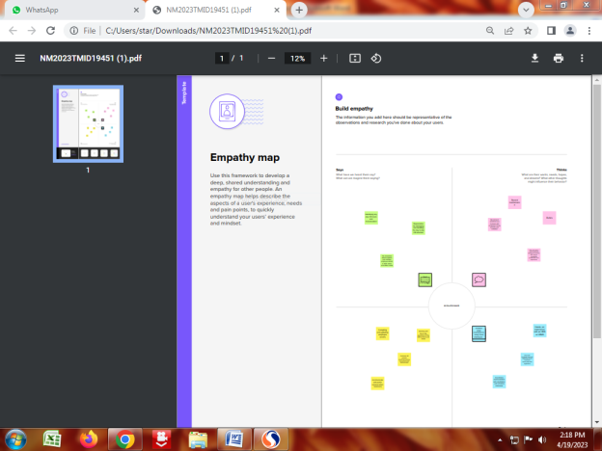

2.2 IDEATION & BRAINSTORMING MAP

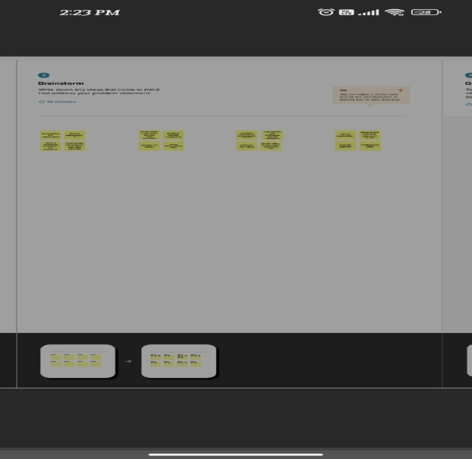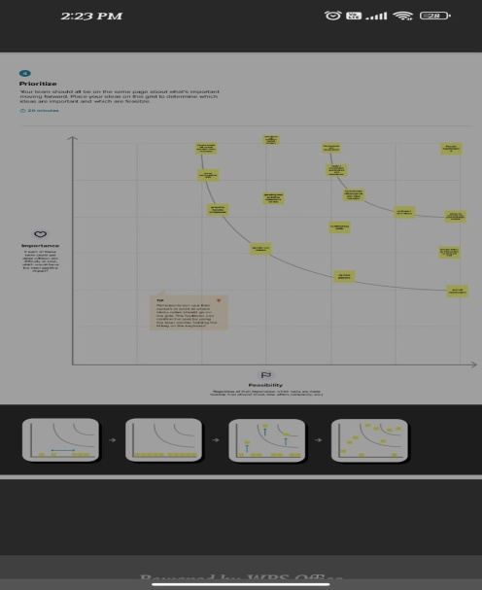

3. RESULT

3.1 DATA MODEL

|  |  |
| --- | --- |
| Object name | Fields in the Object |
| Obj1: JOB POSTING SITE | |  |  | | --- | --- | | Field label | Data type | | Job posting site | Text | | Site name | Num | |
| Obj2:JOB POSTING SITE | |  |  | | --- | --- | | Field label | Data type | | Review | Text | | Review number | Num | |

3.2 ACTIVITY& SCREENSHOT

MILESTONE 1-3:

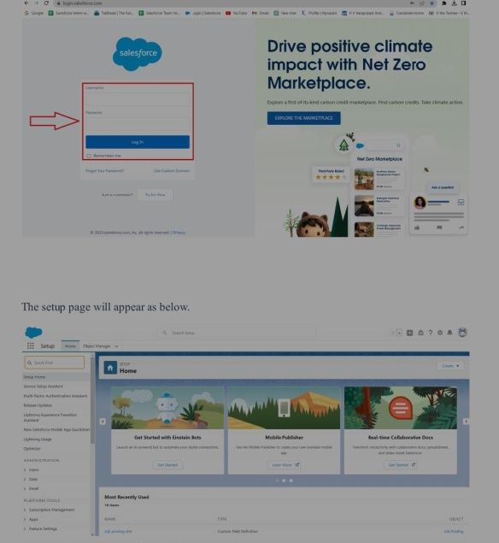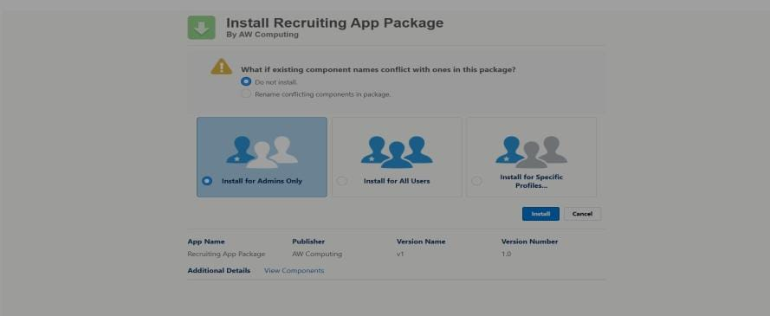

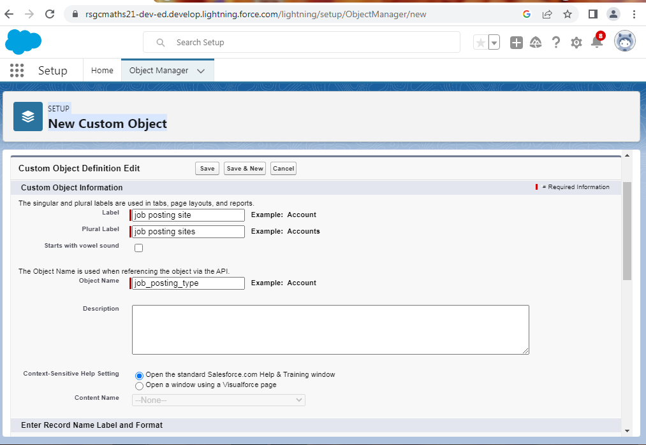

MILESTONE 4-6:

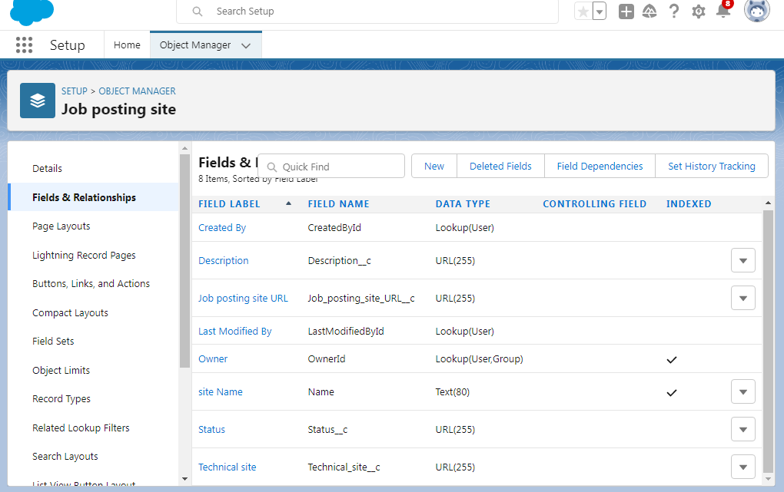

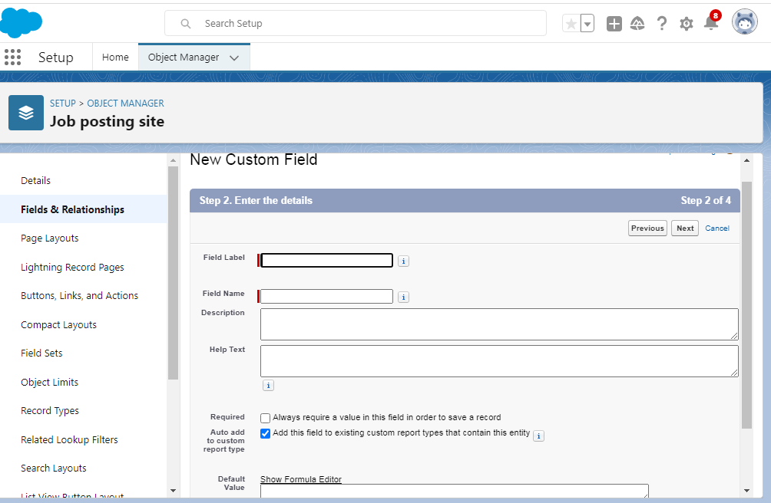

MILESTONE 7-9:

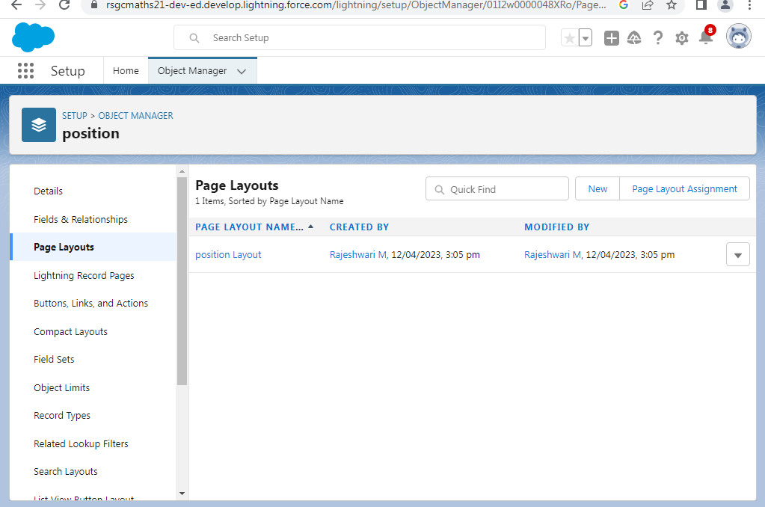

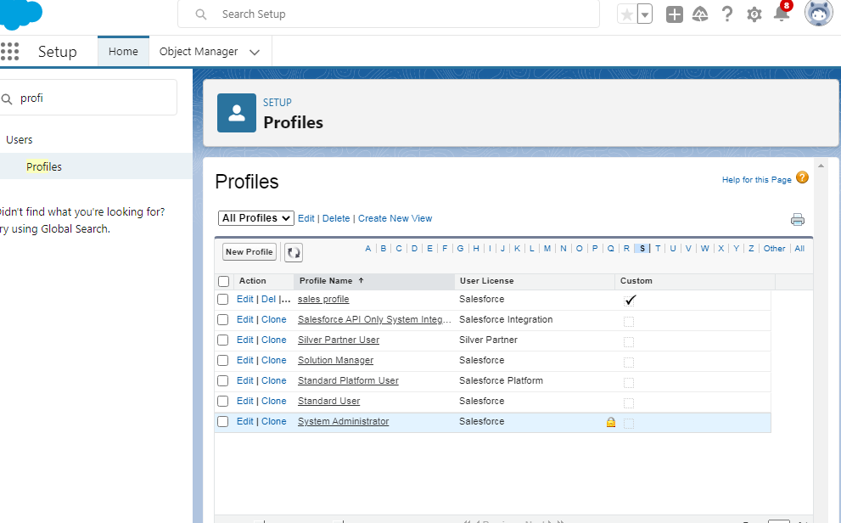

MILESTONE 10-11:

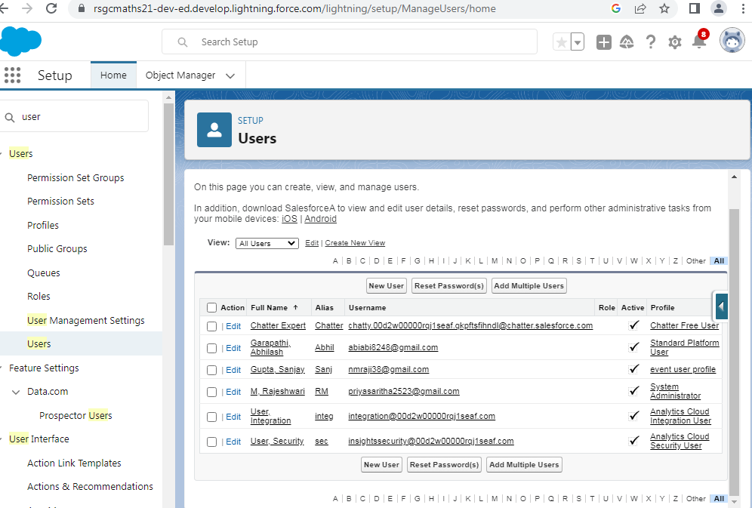

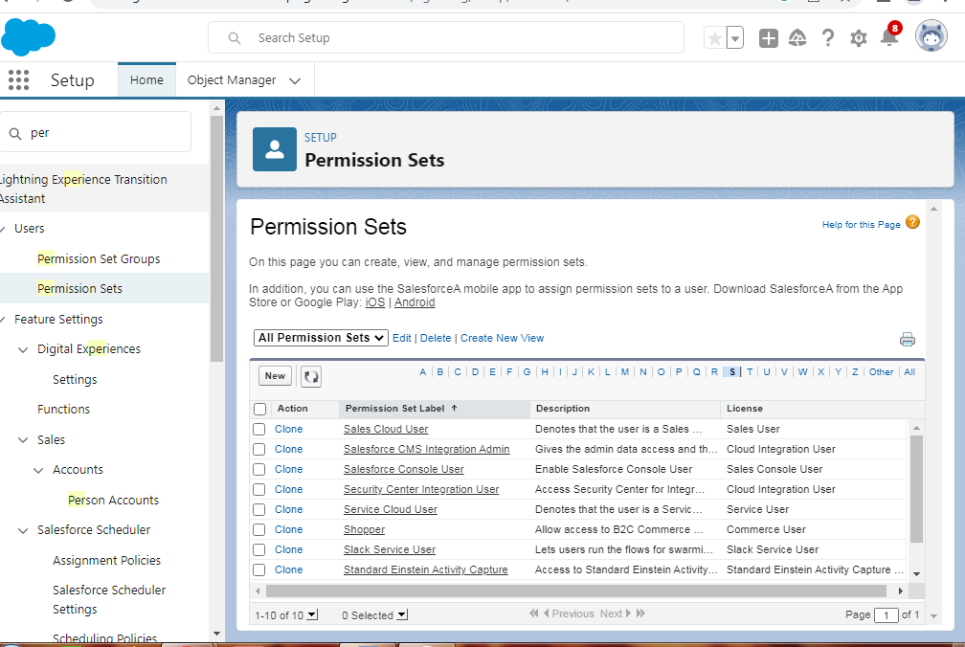4. TRAILHEAD PROFILE PUBLIC URL

TEAM LEAD- <https://trailblazer.me/id/rajeshwari0209>

TEAM MEMBER 1-<https://trailblazer.me/id/sellammal2004>

TEAM MEMBER 2-<https://trailblazer.me/id/abinaya11>

TEAM MEMBER3-<https://trailblazer.me/id/prathiksha1956>

5. ADVANTAGES

* Auto-scheduling tasks

*Scheduling interviews

*Report generation

*On boarding

*Customized hiring

DISADVANTAGE

*The workload is huge: The working demand of the job is huge

*Politics

*Acting as a mediator

*Handling the problems of various people

*Boring cubicle works for new candidates

6. APPLICATIONS

Recruiting Assistants provide support to hiring managers and help them find suitable candidates for a vacant position. Main responsibilities of a Recruiting Assistant are implementing HR functions, providing clerical support, performing background checks, monitoring staff activity, organizing interviews, and helping with payroll preparation. Resume examples in the field mention skills like recruiting experience, organization and planning, labor law knowledge, and familiarity with dedicated software. Employers choose resumes displaying a Bachelor’s Degree in human resources or a related field.

7. CONCLUSION

Proper management of human resources leads to a motivated workforce, a development to loyalty and an assurance of survival and success of an organization. This paper pays a close look at the practice management of human resources in an organization.